Open Polygonal Shapes
# Source: AI Source: Provided by: [Data Path: Persons Table -> ID Column: 1, Name_En Column: Motasem Essam] -> From: [ChatGPT] on [7/25/2026]
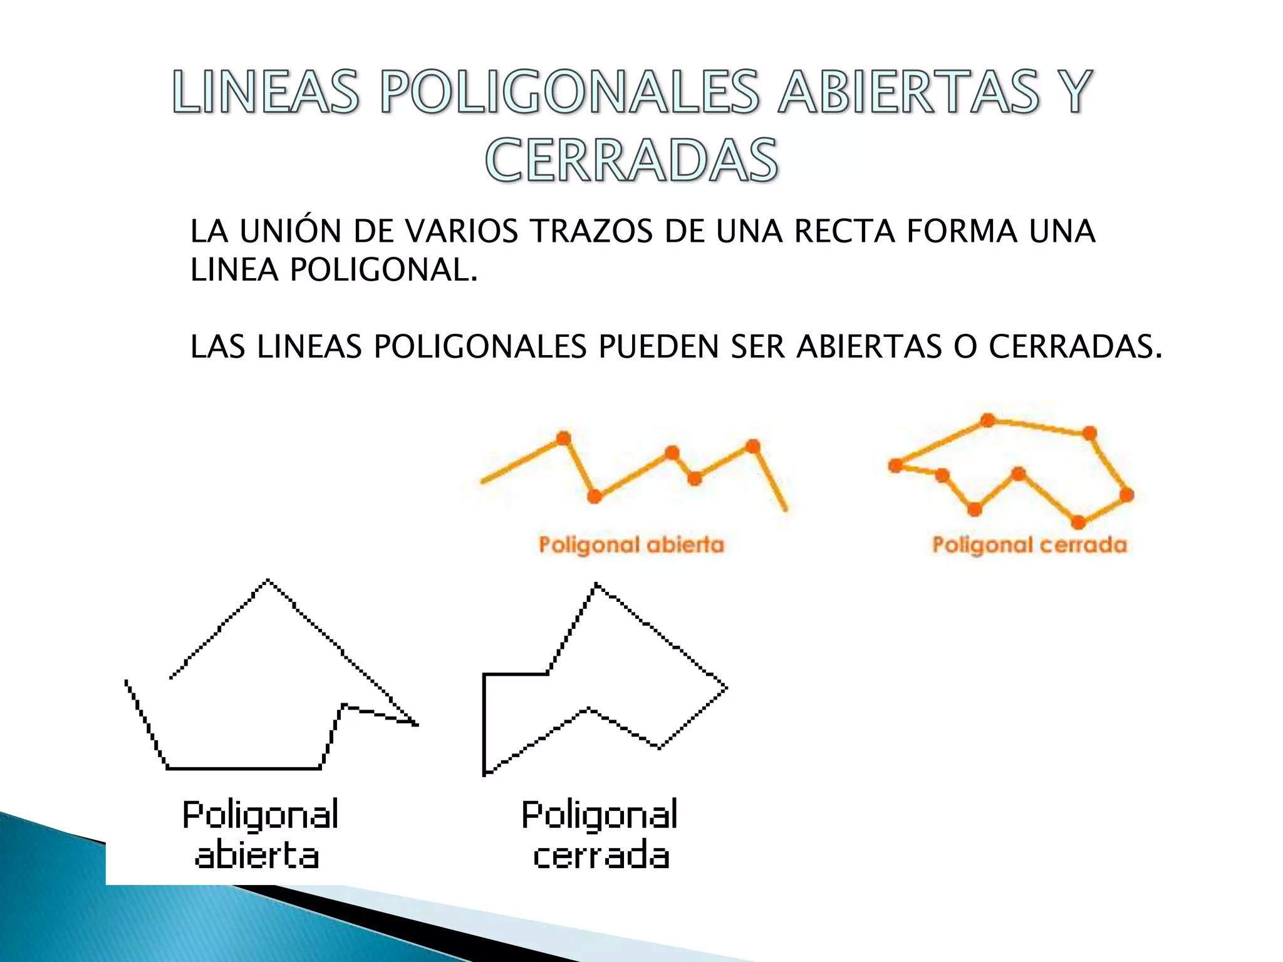
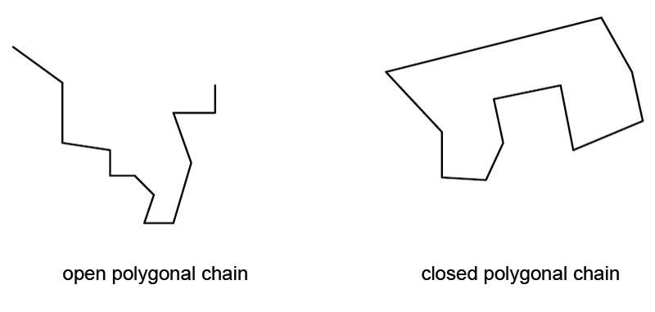
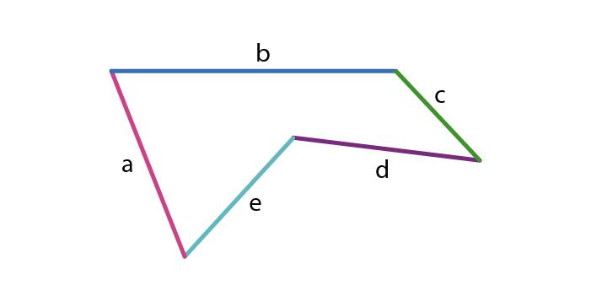
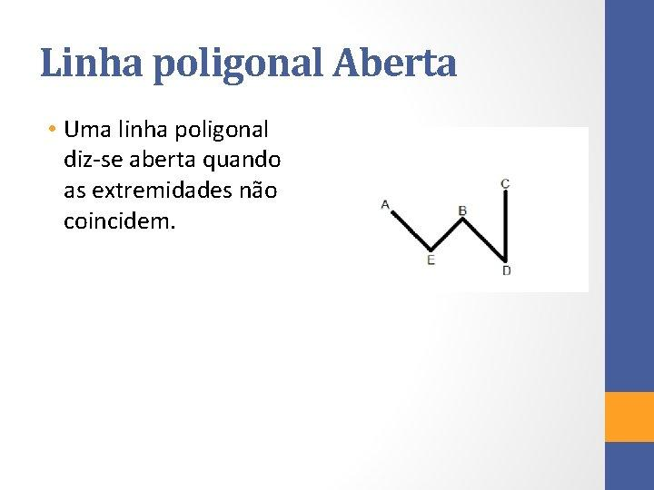
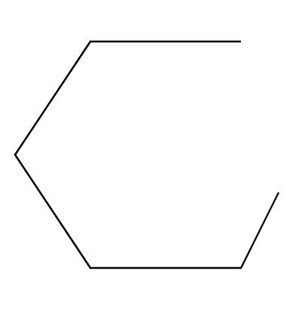

Definition
# Source: AI Source: Provided by: [Data Path: Persons Table -> ID Column: 1, Name_En Column: Motasem Essam] -> From: [ChatGPT] on [7/25/2026]
An Open Polygonal Shape is a plane figure made from two or more connected straight-line segments whose endpoints do not connect to form a closed boundary.
In simple terms:
It is a straight-sided path that does not close back on itself.
$$\boxed{\text{Open Polygonal Shape}=\text{Open}+\text{Straight Segments}+\text{Connected Vertices}}$$
Strictly speaking, in standard geometry, a polygon itself is closed. Therefore, the more precise mathematical term for an open polygonal shape is an open polygonal chain or open polyline.

Characteristics
# Source: AI Source: Provided by: [Data Path: Persons Table -> ID Column: 1, Name_En Column: Motasem Essam] -> From: [ChatGPT] on [7/25/2026]
An open polygonal shape typically:
- Is open.
- Has two distinct endpoints.
- Consists entirely of straight line segments.
- Contains one or more vertices.
- Does not enclose a bounded interior region.
- Does not have a polygonal perimeter in the usual closed-region sense.
- Can have segments of equal or unequal lengths.
- Can have different angles between successive segments.
- May be regular-looking or completely irregular.
The defining condition is:
$$\boxed{P_{\text{start}}≠P_{\text{end}}}$$

Types of Open Polygonal Shapes

1. Open Two-Segment Polygonal Shape
# Source: AI Source: Provided by: [Data Path: Persons Table -> ID Column: 1, Name_En Column: Motasem Essam] -> From: [ChatGPT] on [7/25/2026]
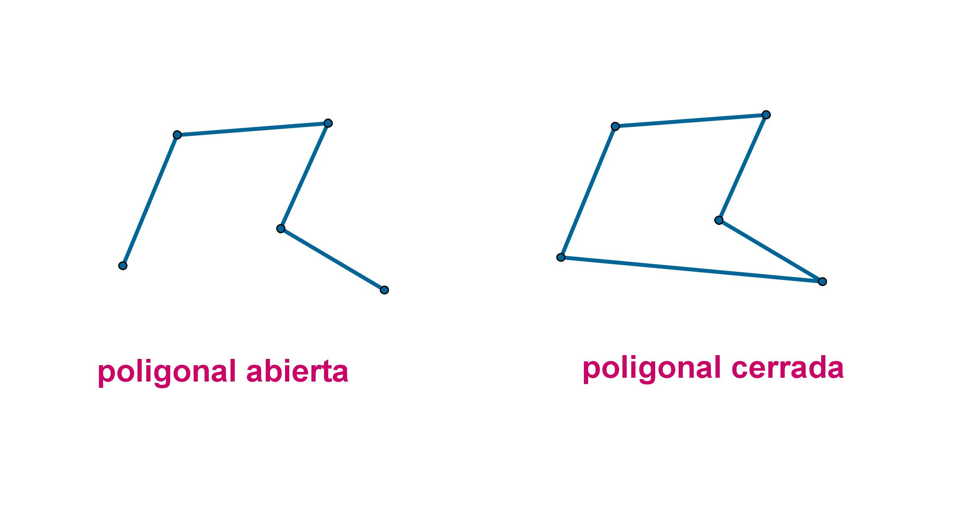
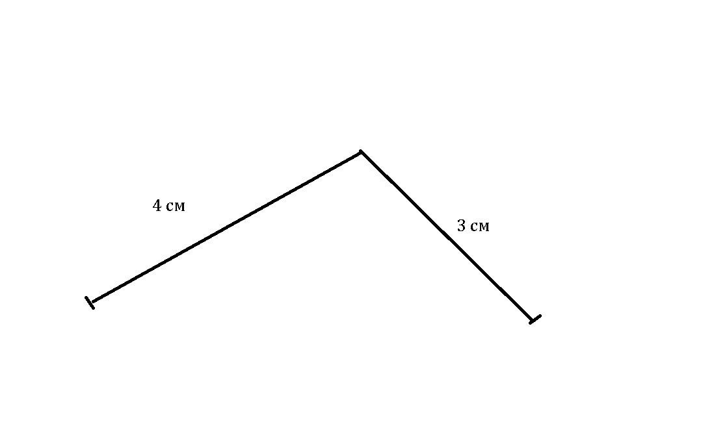
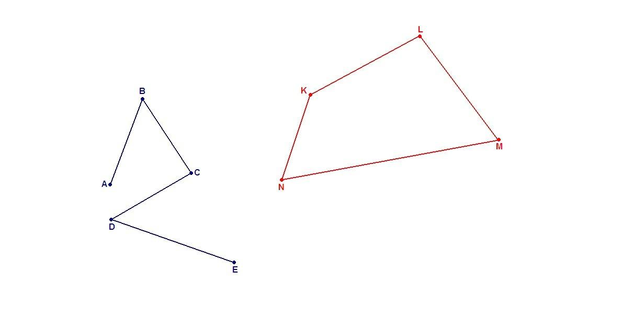
This is the simplest open polygonal chain with a vertex:
$$A→B→C$$
It consists of two connected straight segments.

2. Open Three-Segment Polygonal Shape
# Source: AI Source: Provided by: [Data Path: Persons Table -> ID Column: 1, Name_En Column: Motasem Essam] -> From: [ChatGPT] on [7/25/2026]
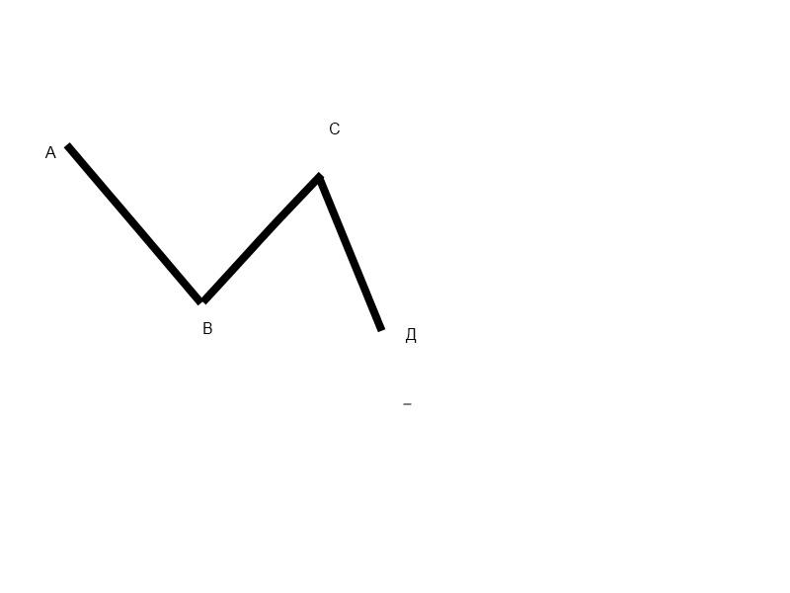
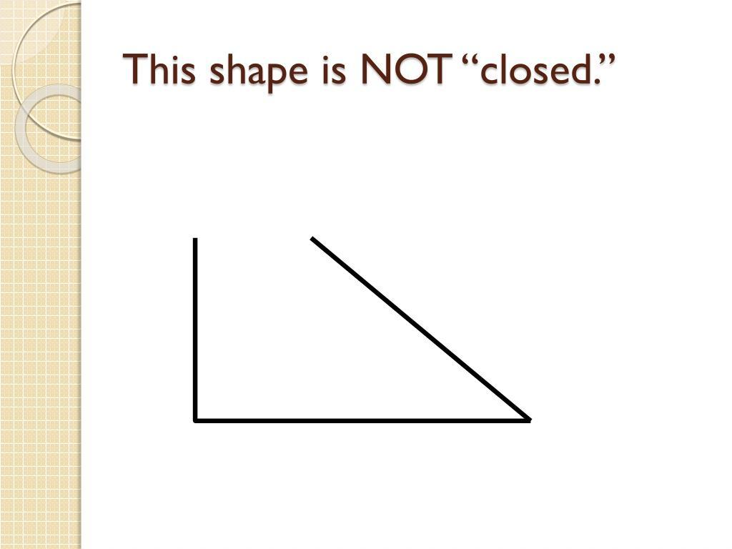
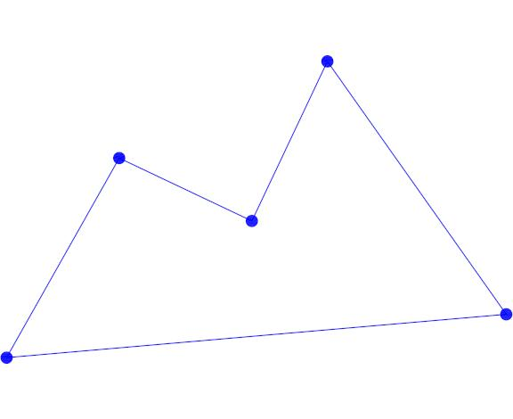
Example:
$$A→B→C→D$$
The final point $D$ does not connect back to $A$.

3. Open Zigzag Polygonal Shape
# Source: AI Source: Provided by: [Data Path: Persons Table -> ID Column: 1, Name_En Column: Motasem Essam] -> From: [ChatGPT] on [7/25/2026]
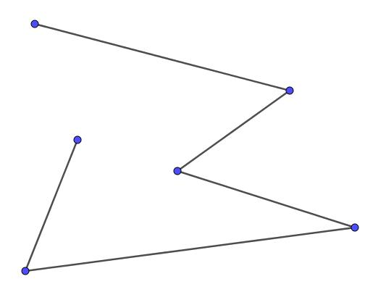
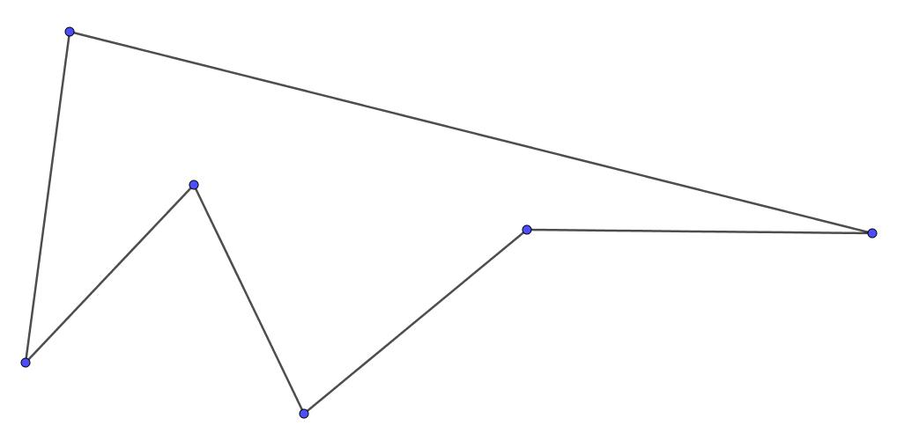
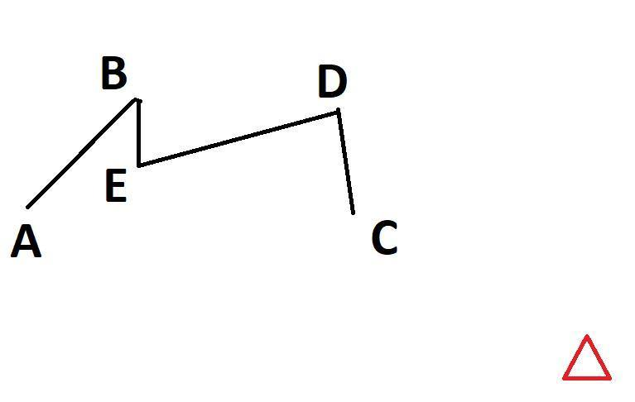
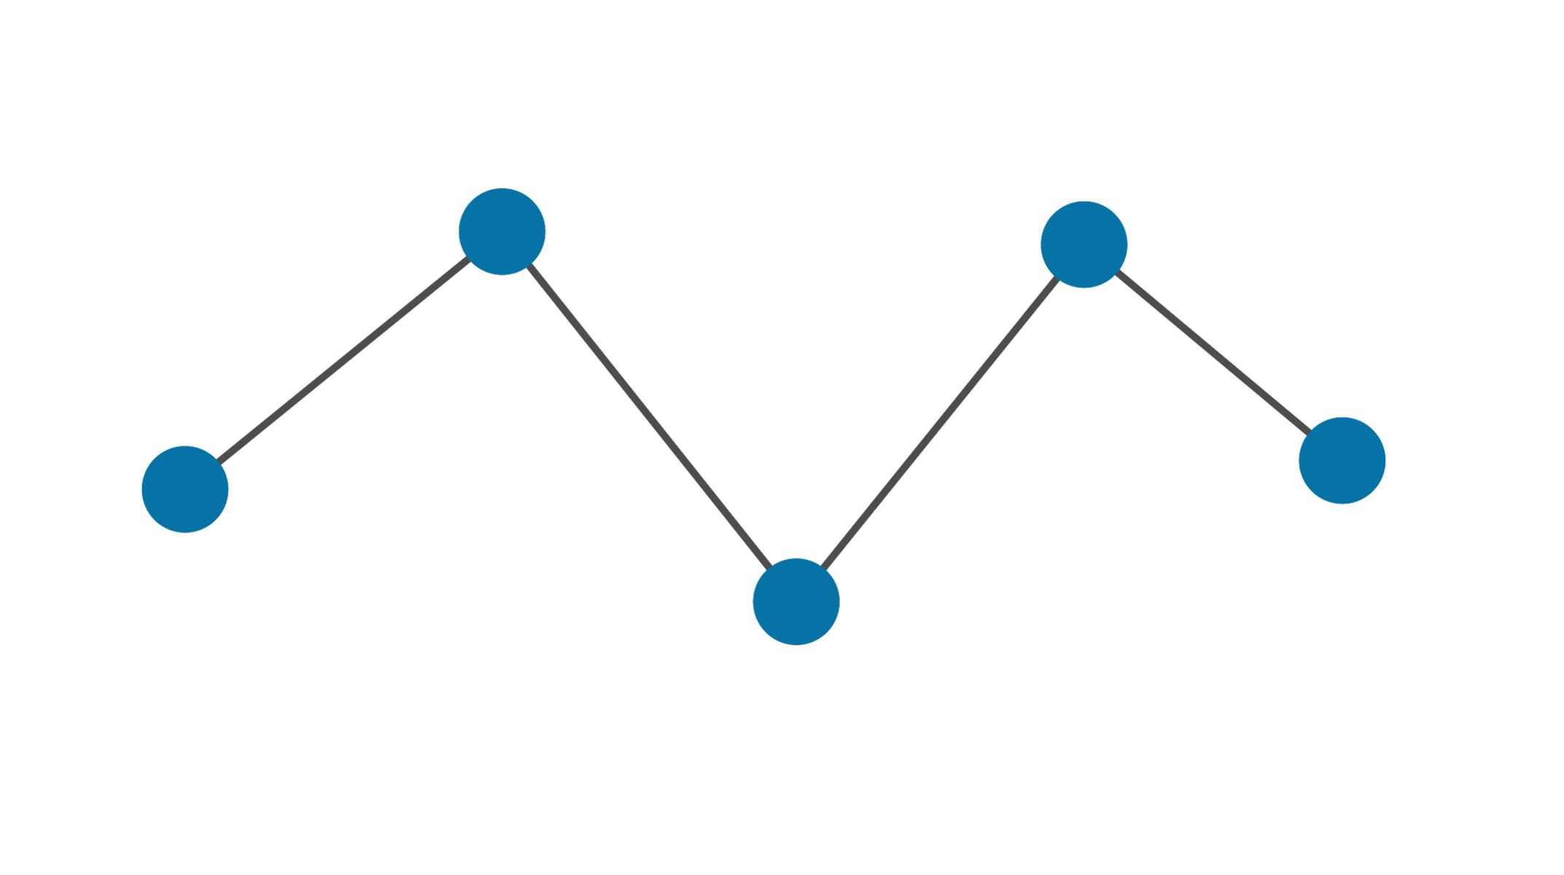
A sequence of straight segments changes direction repeatedly.
$$A→B→C→D→E$$
This is common in diagrams, paths, technical drawings, and graphical representations.

4. Open Irregular Polygonal Shape
# Source: AI Source: Provided by: [Data Path: Persons Table -> ID Column: 1, Name_En Column: Motasem Essam] -> From: [ChatGPT] on [7/25/2026]
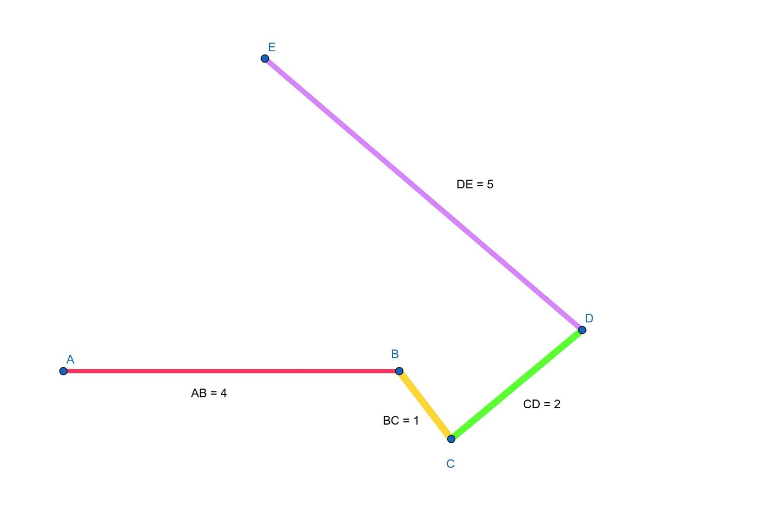
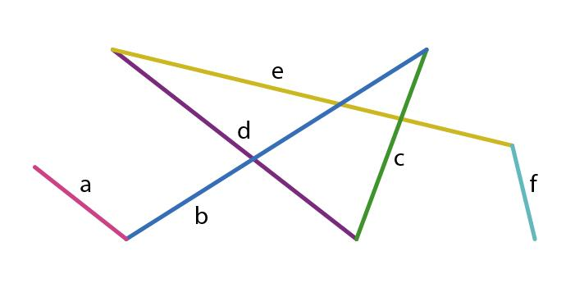
The segments have different lengths and directions.
$$L_{1}≠L_{2}≠L_{3}$$
and the angles between segments may also differ.

5. Open Rectilinear Polygonal Shape
# Source: AI Source: Provided by: [Data Path: Persons Table -> ID Column: 1, Name_En Column: Motasem Essam] -> From: [ChatGPT] on [7/25/2026]
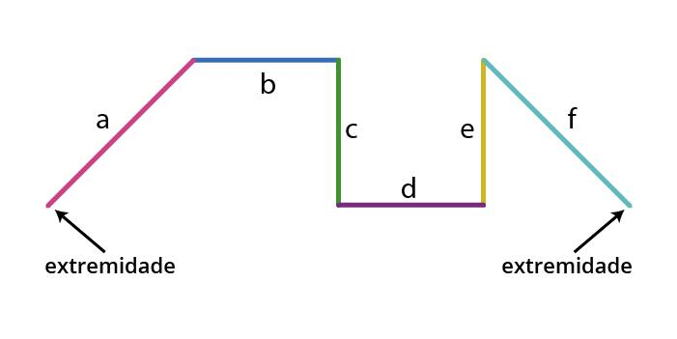
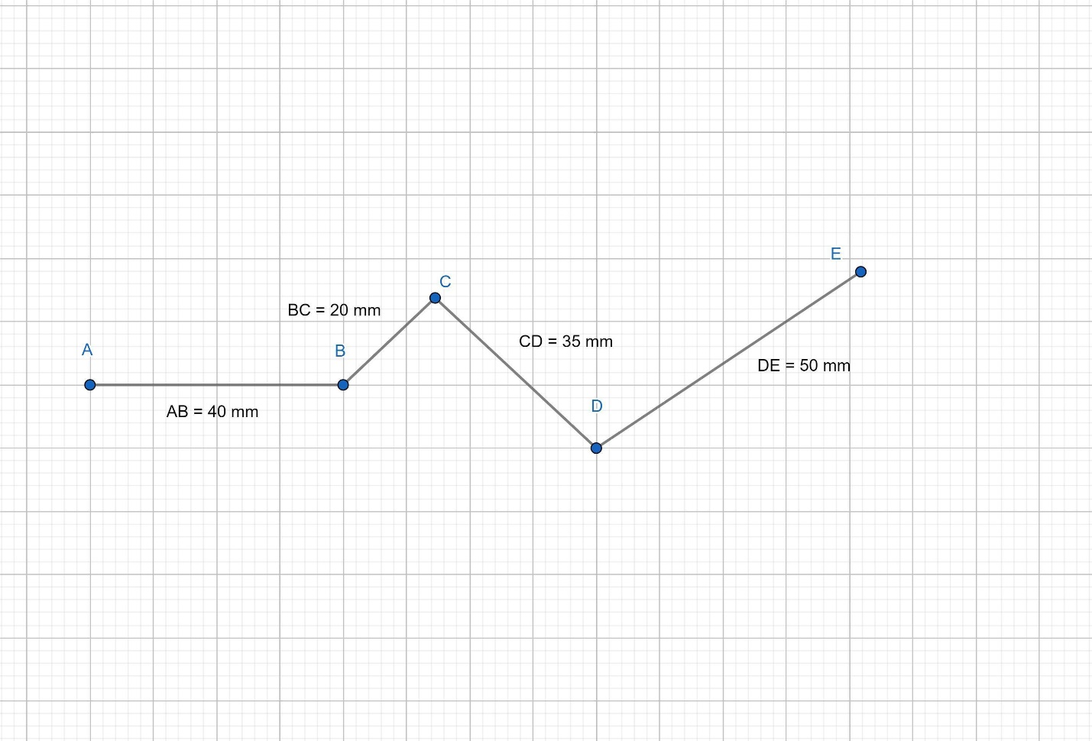
A rectilinear open shape is made only from horizontal and vertical segments.
For example:
$$→↓→↑→$$
It is frequently used in:
- Floor plans
- Maps
- Technical drawings
- Computer graphics
- Coordinate geometry

6. Open Convex-Looking Polygonal Chain
# Source: AI Source: Provided by: [Data Path: Persons Table -> ID Column: 1, Name_En Column: Motasem Essam] -> From: [ChatGPT] on [7/25/2026]
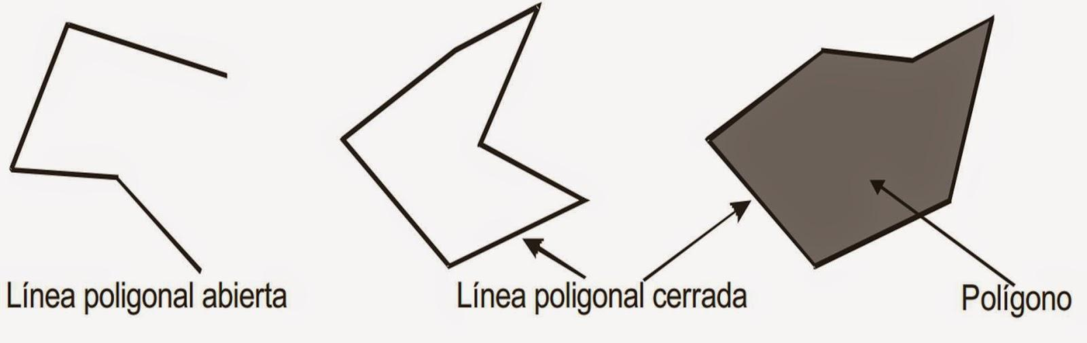
The segments generally turn in a consistent direction without creating an inward indentation.
Note: Since the figure is open, "convex" is not a standard polygon classification in the same sense as for closed polygons. It is better described as a convex-looking or consistently turning open chain.

7. Open Concave-Looking Polygonal Chain
# Source: AI Source: Provided by: [Data Path: Persons Table -> ID Column: 1, Name_En Column: Motasem Essam] -> From: [ChatGPT] on [7/25/2026]
The chain contains inward turns or indentations.
Again, strictly speaking, concavity is formally defined for closed regions, so "concave-looking open polygonal chain" is more precise.

Open vs. Closed Polygonal Shapes
# Source: AI Source: Provided by: [Data Path: Persons Table -> ID Column: 1, Name_En Column: Motasem Essam] -> From: [ChatGPT] on [7/25/2026]
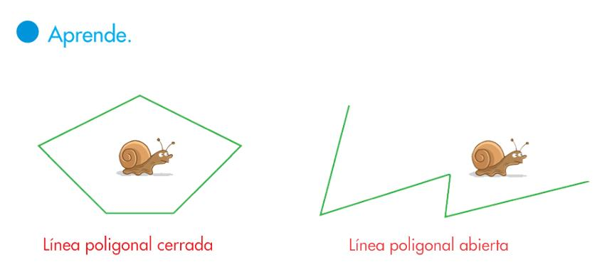
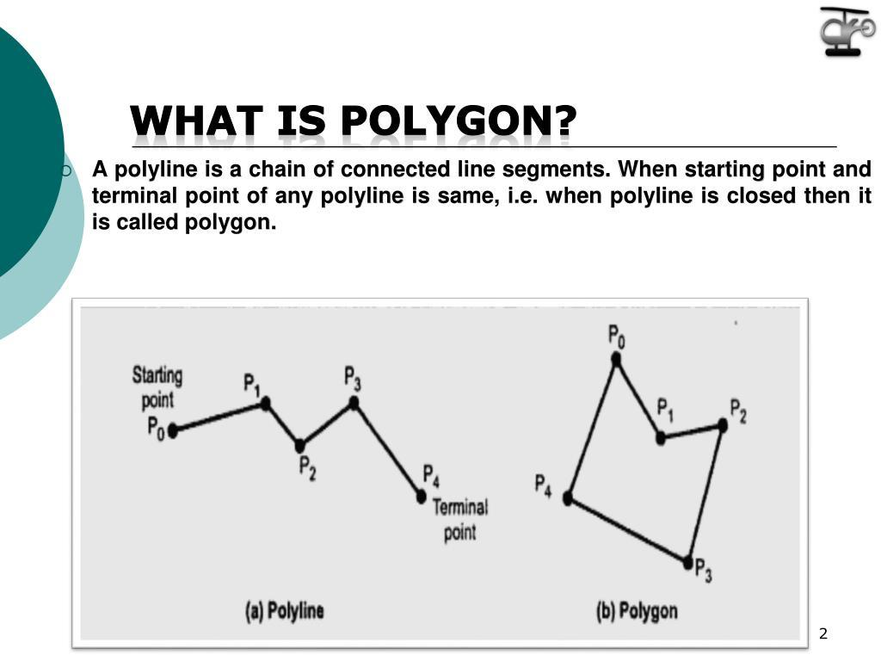
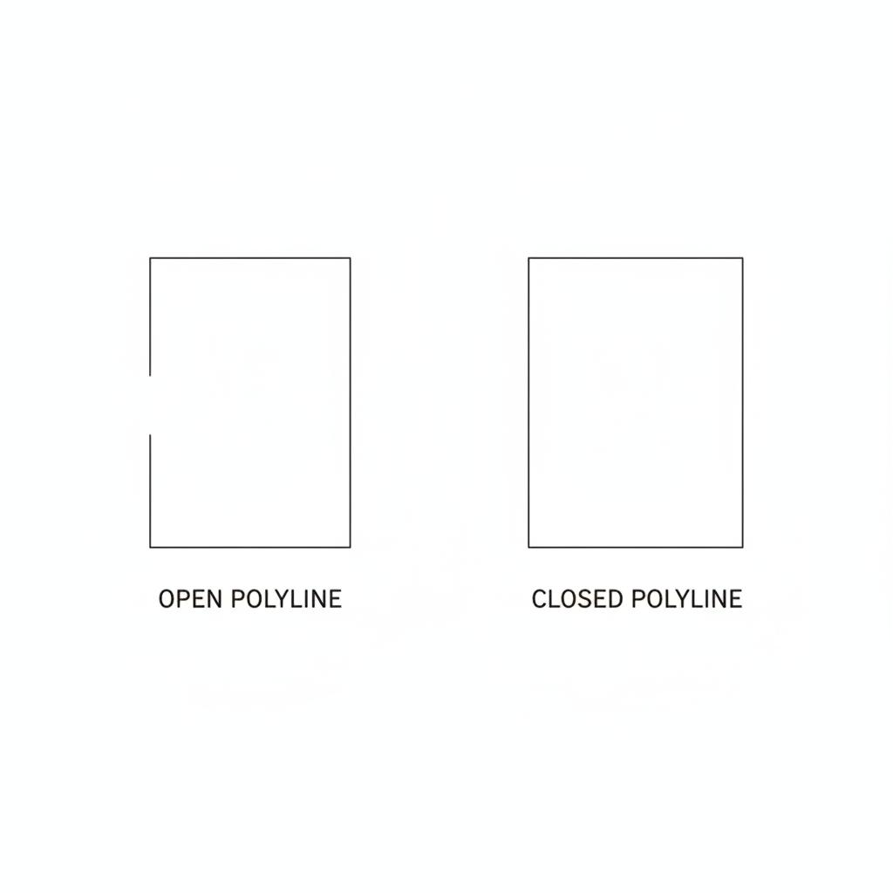
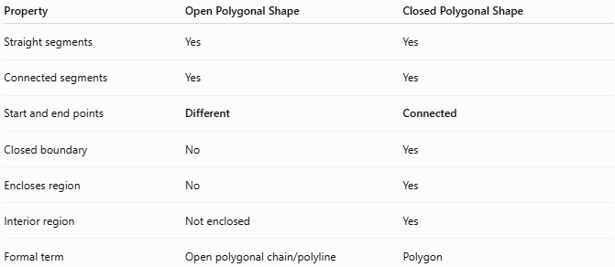
Property | Open Polygonal Shape | Closed Polygonal Shape
Straight segments | Yes | Yes
Connected segments | Yes | Yes
Start and end points | Different | Connected
Closed boundary | No | Yes
Encloses region | No | Yes
Interior region | Not enclosed | Yes
Formal term | Open polygonal chain/polyline | Polygon
The essential difference is:
$$\boxed{P_{\text{start}}≠P_{\text{end}} \text{(open)}}$$
versus:
$$\boxed{P_{\text{start}}=P_{\text{end}} \text{(closed)}}$$

Boundary
# Source: AI Source: Provided by: [Data Path: Persons Table -> ID Column: 1, Name_En Column: Motasem Essam] -> From: [ChatGPT] on [7/25/2026]
An open polygonal shape has a straight, discontinuous closure because its endpoints remain separate.
For a chain:
$$P_{1}→P_{2}→P_{3}→⋯→P_{n}$$
there is no final segment:
$$P_{n}→P_{1}$$
That missing connection is what keeps the shape open.

Area
# Source: AI Source: Provided by: [Data Path: Persons Table -> ID Column: 1, Name_En Column: Motasem Essam] -> From: [ChatGPT] on [7/25/2026]
An open polygonal chain does not enclose an area by itself.
$$\boxed{A_{\text{enclosed}}=0}$$
This does not mean the line segments have zero geometric length. Rather, they do not bound a two-dimensional region.
If additional segments are added to close the chain, it can become a closed polygon with a measurable area.

Length
# Source: AI Source: Provided by: [Data Path: Persons Table -> ID Column: 1, Name_En Column: Motasem Essam] -> From: [ChatGPT] on [7/25/2026]
Unlike area, the total length of an open polygonal chain can be measured:
$$\boxed{L=L_{1}+L_{2}+⋯+L_{n}}$$
where $L_{i}$ is the length of each straight segment.
For coordinate points $P_{i}=\left(x_{i},y_{i}\right)$:
$$L_{i}=\sqrt{{\left(x_{i+1}-x_{i}\right)}^{2}+{\left(y_{i+1}-y_{i}\right)}^{2}}$$
Therefore:
$$\boxed{L=\sum_{i=1}^{n-1}{\sqrt{{\left(x_{i+1}-x_{i}\right)}^{2}+{\left(y_{i+1}-y_{i}\right)}^{2}}}}$$

Key Points
# Source: AI Source: Provided by: [Data Path: Persons Table -> ID Column: 1, Name_En Column: Motasem Essam] -> From: [ChatGPT] on [7/25/2026]
An Open Polygonal Shape is:
$$\boxed{\text{Open}+\text{Straight-Sided}+\text{Connected Segments}}$$
It has:
- Two distinct endpoints.
- Straight-line segments only.
- One or more vertices.
- No closed boundary.
- No enclosed interior region.
- A measurable total length.
Important terminology
For mathematical precision:
$$\boxed{\text{Open Polygonal Shape}≈\text{Open Polygonal Chain / Open Polyline}}$$
while:
$$\boxed{\text{Closed Polygonal Shape}=\text{Polygon}}$$

Conclusion
# Source: AI Source: Provided by: [Data Path: Persons Table -> ID Column: 1, Name_En Column: Motasem Essam] -> From: [ChatGPT] on [7/25/2026]
Open Polygonal Shapes are open straight-sided figures formed from connected line segments that do not connect their final endpoint back to their initial endpoint. They are more precisely called open polygonal chains or open polylines. They can be classified according to their segment arrangement, such as zigzag, irregular, or rectilinear, and they are fundamentally different from closed polygons because they do not enclose a bounded region.

